EXECUTIVE SUMMARY

RESETTLEMENT ACTION PLAN

For

Rongrenggre–Simsanggre–Nengkhra (RSN) Road-ni improvement aro
widening Meghalaya Logistics aro Connectivity Improvement Project
(MLCIP)-ni bikma, World Bank-ni funding-ni bikma.

Submitted To

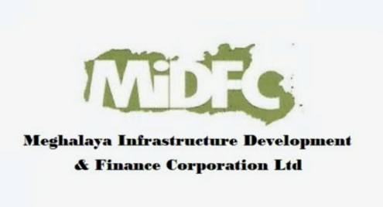

Meghalaya Infrastructure Development Finance Corporation (MIDFC) Ltd.
House No. L/A-56, Lower Nongrim Hills, Top Floor,
Meghalaya Basin Development Authority (MBDA) Building,
Shillong East Khasi Hills, Meghalaya-793003

EXECUTIVE SUMMARY

1. Project Background

Meghalaya Logistics aro Connectivity Improvement Project (MLCIP), World Bank aro Meghalaya Government-ni funding-ni bikma, state-ni connectivity, logistics efficiency aro climate-resilient transport infrastructure-ni bikma. RSN Road (Rongrenggre–Simsanggre–Nengkhra, 22 km) improvement aro widening-ni sub-project East Garo Hills District-ni bikma. Road-ni bikma rural settlements-ni markets, healthcare facilities aro administrative centers-ni connect-ma bikma corridor-ni bikma.
2. Need for the Resettlement Action Plan
RAP-ni bikma road widening-ni existing Right of Way (RoW)-ni bikma social impacts-ni address-ma bikma. Project Sixth Schedule area-ni bikma, land ownership aro governance customary institutions-ni bikma. All affected households-ni Scheduled Tribe communities-ni bikma. RAP World Bank ESF (ESS5 aro ESS7), national aro state regulations-ni compliance-ma bikma aro Free, Prior aro Informed Consent (FPIC)-ni bikma indigenous land rights aro livelihoods protect-ma bikma.
3. Project Impacts and Affected Population
Project-ni impacts minor aro localized, existing RoW-ni bikma. No additional land acquisition-ni required. Impacts include partial impact-ni residential structures, temporary shops, fencing aro minor commercial assets. Total 40 Project-Affected Households (PAHs) aro 90 Project-Affected Persons (PAPs) 100% census-ni bikma identify-ma bikma. All affected persons predominantly Garo aro Rabha Scheduled Tribe-ni bikma.
4. Socio-Economic Profile
Project corridor 7 villages aro 14 habitations-ni bikma pass-ma bikma, rural settlements aro predominantly tribal population-ni characteristic-ni bikma. Livelihoods petty trade, agriculture, wage labor aro services-ni bikma. Literacy aro income levels villages-ni bikma vary-ma bikma. Women-headed households 45% aro elderly persons affected population-ni bikma included. Social structure customary land tenure aro matrilineal inheritance practices (Garo community) influence-ma bikma.
5. Consultation, Disclosure, and FPIC
Village aro district levels-ni extensive consultations project preparation-ni bikma conduct-ma bikma. Three rounds FPIC consultations PAPs, Nokmas (village headmen), GHADC officials aro community representatives-ni bikma conduct-ma bikma project details disclose-ma, impacts assess-ma aro community consent confirm-ma. Consultations culturally appropriate aro local languages-ni bikma. Feedback project design aro mitigation measures-ni bikma integrate-ma bikma. RAP disclosure aro stakeholder engagement implementation-ni bikma continue-ma bikma.
6. Eligibility and Entitlements
Eligibility includes titleholders, non-titleholders (encroachers aro squatters), aro vulnerable households-ni CoI-ni bikma affected. Entitlements MPWD Entitlement Matrix-ni bikma define-ma bikma, RFCTLARR Act, 2013 aro World Bank ESF-ni aligned-ma bikma. Structures-ni compensation full replacement cost-ni bikma provide-ma bikma, resettlement assistance, livelihood support aro Grievance Redress Mechanism (GRM) access-ni bikma provide-ma bikma, living standards restore aro improve-ma ensure-ma bikma.
7. Institutional Arrangements and Grievance Redress
RAP Meghalaya Public Works Department (PWD)-ni bikma implement-ma bikma, E&S Cell, district administration aro GHADC-ni support-ma bikma. Two-tier Grievance Redress Mechanism (GRM) complaints-ni transparent aro time-bound manner-ni address-ma bikma, village, district aro state levels-ni accessible-ma bikma.
8. Implementation Schedule and Budget
RAP phased manner-ni bikma implement-ma bikma, civil works-ni synchronize-ma bikma. All compensation aro assistance construction-ni affected sections start-ma prior pay-ma bikma. Total Resettlement aro Rehabilitation (R&R) budget structures compensation, resettlement assistance, livelihood restoration, administrative costs, monitoring aro contingencies-ni bikma include-ma bikma.
9. Monitoring and Evaluation
Internal aro external monitoring mechanisms RAP effective implementation-ni bikma ensure-ma bikma. Monitoring indicators physical progress, financial disbursement, grievance redress aro livelihood restoration outcomes-ni cover-ma bikma. Impact evaluation affected households-ni living standards restore aro improve-ma able-ma bikma assess-ma bikma.
10. Grievance Redress Mechanism
Flowchart-ni bikma two-tier grievance redressal mechanism, responsibilities aro timelines resolution-ni illustrate-ma bikma.

Tier I: Project Site Level | Responsibility: VECs (Village Executive Committees) aro Nokma/Headman  Timeline: Resolution 15 sngi-ni bikma  If unresolved → Escalate to PMU (Tier II)
Tier II: State Level (PMU) | Responsibility: Secretary Planning, Chief Engineer,  Project Director, Social Expert  Timeline: Resolution 15 sngi-ni bikma

Grievance Redressal Mechanism
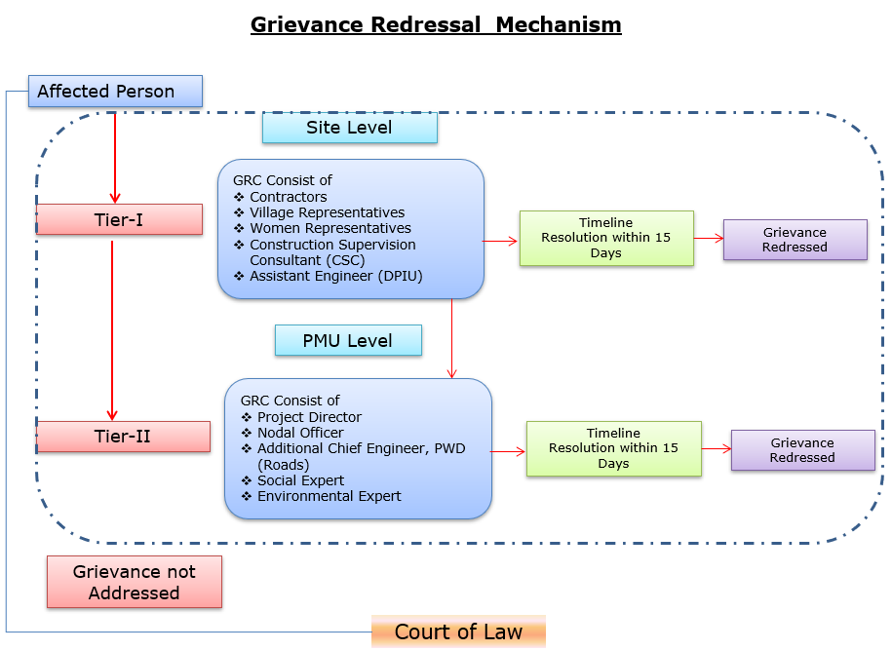

Details of contact for Grievances
Description | Contact details
Company: | PWD, Meghalaya
To: | Chief Engineer-cum-Nodal officer
Address: | HV9P+GFJ, Lachumiere, Shillong, Meghalaya 793001
E-mail: | esmlcip@gmail.com
Website: | http://megpwd.gov.in/contacts.html
Telephone: | Tel: 0364-3572466
Fax: | -

11. Conclusion
RAP jong ka Rongrenggre–Simsanggre–Nengkhra (RSN) dakma ka jingmawphlang jong ka project ha ka kam jong ka jingpynsñia ka jingmawphlang kaba kham kongsan, ka jingpynshisha ka riar jong ki jaka-kaba-bun, aro ka jingpynïaid kaba kaba kongsan ha ka jingim jong ki briew. Ha kaba dang donkam kam, ka jingmawphlang kaba kham phang ha ki shnong kiba la khlem shong, ka jingkylla ka kongsan jong ki paidbah, aro ka jingtreikam kaba donkam ha ki kam pynthikna, ka project ka la kren kham shong ka jingdonkam ka jingtip kaba kaba kongsan ka jingim aro ka jingiaid kaba donkam ha ki paidbah kiba la khlem shong.

